MCO1
Team Name | Group 7
Team Members (Name — Role) | Agunanne Henry – Member | Linc Chan – Member
Project Name | Archers Airline Flight Reservation and Booking System
Project Domain | Airline, Travel, Flight Reservation, Booking
Reusing a CCAPDEV/CCDEVAP project? (Y/N) | Y
Submission Date | Friday, October 9, 2026

SECTION 1 — RISK ASSESSMENT
Complete the asset inventory and risk register below. Score Likelihood and Impact strictly against the 5×5 matrix in the Specification (Section 2). Sort the register by risk level, highest first.
1.1 Asset Inventory
Asset ID | Asset Name | Description / Why It Matters
A-01 | User Accounts | Registered accounts (models/User.js) holding first and last name, email, password hash, date of birth and role (User or Admin). A compromised or altered account exposes that person’s bookings; the Admin role controls every flight and booking.
A-02 | User Authentication Data | Credentials and authentication/session information used to establish a user's identity. Compromise could result in account takeover.
A-03 | Passenger Personal Information | Passenger names, ages, genders, passport information, and other passenger details associated with reservations. This contains personal and potentially sensitive personal information.
A-04 | Reservation Records | Booking information including user association, flights, trip type, travel class, passengers, price, booking date, and reservation status.
A-05 | Flight Information | Flight numbers, origins, destinations, schedules, aircraft, seat capacity, prices, and flight status.
A-06 | Seat / Capacity Information | Seat assignments and flight capacity information used to support reservation availability and prevent conflicting bookings.
A-07 | Reservation Transaction State | The integrity of booking, cancellation, and supported modification operations, including reservation status.
A-08 | Administrative Flight Management | Administrative functions used to create, edit, delete, and manage flight information and status.
A-09 | Application / API Layer | Express routes, reservation endpoints, authentication middleware, AJAX/fetch endpoints, and server-side application logic that enforce business rules.
A-10 | MongoDB Database | Persistent storage containing user, flight, reservation, and related application records.
A-11 | User Sessions | Active authenticated sessions that maintain a user's authenticated state while using the application.
A-12 | Audit / Security Records | Records needed to attribute bookings, cancellations, admin changes and logins. Today these are only the winston log files in logs/ (combined.log, errors.log), which are committed to the public repository and can be edited; REQ-N-03 moves audit entries into a separate collection.
A-13 | Application Availability | Availability of the reservation website and its database/application services, particularly during flight-search and booking operations.
A-14 | Application Dependencies | Node.js packages, Express/Mongoose components, frontend libraries, and other software dependencies required for the application to operate.
A-15 | Application Secrets and Seed Accounts | The session signing secret and database connection string (both hardcoded in app.js) and the accounts seeds/seedUsers.js creates, including an Admin account with a fixed password. The repository is public, so these values must be treated as known to anyone.

1.2.1 Risk Register
Risk ID | Asset / Threat | Likelihood (1–5) | Impact (1–5) | Score | Risk Level | Disposition (Requirement Needed → Req ID, or Accepted + justification)
R-16 | A-15/A-01 — A seeded Admin account with a fixed, public password (seeds/seedUsers.js: admin@example.com / adminpass, auto-seeded on an empty DB by app.js) lets anyone who reads the public repo sign in as administrator (external attacker) | 4 | 5 | 20 | Critical | Requirement Needed → REQ-AA-04
R-01 | A-04/A-09 — No ownership check on reservation reads (GET /reservations/:id, /:id/confirmation): a logged-in user changes the reservation id in the request to view another user’s booking and passport data (malicious authenticated user) | 4 | 4 | 16 | Critical | Requirement Needed → REQ-C-01, REQ-AA-02
R-02 | A-06/A-07 — Seat/capacity is not re-checked when a booking is saved (POST /reservations/create stores the seats the browser sent): simultaneous or crafted bookings double-book a seat or exceed capacity (any user; concurrency) | 4 | 4 | 16 | Critical | Requirement Needed → REQ-I-02
R-06 | A-07/A-09 — The server trusts the price from the browser (POST /reservations/create and /:id/edit store totalAmount from the request body): a user edits one field to book at any price (malicious user) | 4 | 4 | 16 | Critical | Requirement Needed → REQ-I-01
R-05 | A-07/A-09 — No ownership check on cancel/modify (POST /reservations/cancel/:reservationId, /:id/edit, /update/:id): a logged-in user submits another user’s reservation id to cancel or change their booking (malicious authenticated user) | 4 | 4 | 16 | Critical | Requirement Needed → REQ-AA-02
R-03 | A-03/A-10 — Bulk disclosure of passenger records incl. passport numbers through over-full responses, the committed logs, or an unencrypted connection (external attacker or insider) | 3 | 5 | 15 | High | Requirement Needed → REQ-C-01, REQ-C-02, REQ-C-03, REQ-C-05
R-17 | A-01/A-09 — Privilege escalation via profile edit (POST /users/edit/:userId has no ownership check and then sets req.session.user to the edited account): a user edits the Admin record — whose _id appears in the committed logs — and is served an admin session (malicious authenticated user) | 3 | 5 | 15 | High | Requirement Needed → REQ-AA-02, REQ-AA-04
R-04 | A-01/A-02 — Account compromise: login (POST /users/login) reveals whether an email exists and has no rate-limit or lockout, and seeded users share password123 (external attacker, credential stuffing) | 3 | 4 | 12 | High | Requirement Needed → REQ-AA-01, REQ-AA-03
R-07 | A-08/A-09 — Unauthorized flight changes: although /admin enforces an Admin role, a stolen admin session or the seeded admin lets flight create/edit/delete/status be changed (compromised admin / external attacker) | 3 | 4 | 12 | High | Requirement Needed → REQ-AA-02, REQ-AA-03, REQ-I-04, REQ-N-02
R-08 | A-09/A-11 — Session compromise/forgery: the session secret is hardcoded in the public repo (app.js, 'AASecret23'), cookies are only Secure in production (npm start doesn’t set it), and the session id is not regenerated at login (external/network attacker) | 3 | 4 | 12 | High | Requirement Needed → REQ-AA-03, REQ-C-02, REQ-C-04
R-09 | A-09/A-10 — Unvalidated input reaches Mongoose queries (login, search and check-in build queries from req.body/req.query): NoSQL-style operators or malformed input could bypass checks or read/alter records (external attacker) | 3 | 4 | 12 | High | Requirement Needed → REQ-I-03, REQ-I-06, REQ-C-03
R-10 | A-13 — No rate limiting anywhere: automated flooding of search, login or booking endpoints degrades or downs the service (automated attacker, bot) | 3 | 4 | 12 | High | Requirement Needed → REQ-A-01
R-18 | A-01/A-09 — Any user can delete any account (POST /users/delete/:userId; its role check only blocks admins, so a regular user can delete any account including Admin) (malicious authenticated user) | 3 | 4 | 12 | High | Requirement Needed → REQ-AA-02
R-19 | A-09/A-03 — Stored XSS: passenger seat values are rendered into an inline script without escaping ({{{occupiedSeats}}} in reservation.hbs and edit-reservation.hbs), so a crafted seat value runs in other users’ browsers on that flight’s booking page (malicious authenticated user) | 3 | 4 | 12 | High | Requirement Needed → REQ-I-06
R-20 | A-03/A-12 — Personal data committed to the public repo: logs/combined.log contains names, emails and user _ids with login events, and is tracked in git (realized exposure; external attacker) | 4 | 3 | 12 | High | Requirement Needed → REQ-C-05, REQ-N-03
R-11 | A-10 — Database failure or accidental wipe loses all bookings and passenger records with no tested backup (operational failure) | 2 | 5 | 10 | High | Requirement Needed → REQ-A-02
R-12 | A-12 — Audit evidence is insufficient: actions go only to editable flat log files (logs/) without a consistent actor, timestamp and target, so significant actions can’t be reliably attributed (careless or malicious user or admin) | 3 | 3 | 9 | Medium | Requirement Needed → REQ-N-01, REQ-N-02, REQ-N-03
R-13 | A-14 — Known-vulnerable dependencies: npm audit reports 30 known issues (10 critical), mostly from the unused handlebars-helpers package, and parts of node_modules are committed (compromised dependency) | 2 | 4 | 8 | Medium | Requirement Needed → REQ-I-05
R-14 | A-04/A-07 — A user denies creating, cancelling, or changing a booking and there’s no reliable attributable record to settle the dispute (user or compromised account) | 2 | 3 | 6 | Medium | Requirement Needed → REQ-N-01, REQ-N-03
R-15 | A-03 — Disclosure of a passenger’s meal preference outside their booking; the Gluten-Free option can indicate a health condition (malicious insider or external attacker) | 2 | 3 | 6 | Medium | Requirement Needed → REQ-C-01

1.2.2 Score Justifications
Risk ID | Likelihood Justification | Impact Justification
R-01 | 4, Likely: editing a reservation ID in a request needs no skill or tools, and IDs are sent every time a user opens a booking, so without an ownership check this will probably happen. | 4, Major: each exposed booking shows passenger names, ages and passport numbers, so even one case is a reportable Data Privacy Act breach.
R-02 | 4, Likely: every booking includes seat selection, so on busy flights two users picking the same seat at the same moment will probably happen. | 4, Major: wrong capacity or conflicting seat records affect every passenger booked on that flight and every later booking for it (large-scale), the same reach as a wrong flight change in R-07.
R-03 | 3, Possible: all passenger data sits in one database the app reads constantly, so a leak through a misconfiguration, backup or over-full response might happen at some point during normal operation. | 5, Catastrophic: a bulk leak of passport numbers is a mass sensitive-data breach with severe legal consequences under the DPA.
R-04 | 3, Possible: the login page is public and people reuse passwords, so a guessed or stolen password might work at some point during normal operation. | 4, Major: a taken-over account exposes that user’s bookings and passengers’ passport details, which is a reportable DPA breach.
R-05 | 4, Likely: cancel and modify use the same id-in-request pattern as R-01 with no ownership check (/reservations/cancel/:id, /:id/edit), so this will probably occur. | 4, Major: cancelling or altering another passenger’s booking changes their data without authorization (a DPA personal-data breach) and can cause a missed flight.
R-06 | 4, Likely: the booking request carries totalAmount and the server stores it as the price (/reservations/create), so a price change with browser dev tools will probably occur once noticed. | 4, Major: the same edit works on every booking, so pricing integrity breaks at scale, not for one user.
R-07 | 3, Possible: admin routes can be called directly by URL and admin passwords can be stolen, so this might happen at some point during normal operation. | 4, Major: one wrong flight change affects every passenger booked on that flight and every new booking (large-scale).
R-08 | 3, Possible: the signing secret is public in app.js and cookies aren’t Secure outside production, so forging or stealing a session is feasible during normal operation. | 4, Major: a forged or stolen session grants that user’s — or an admin’s — access to bookings and passport data.
R-09 | 3, Possible: every form and API request is an entry point, and automated scanners routinely try injection on public sites, so this might happen at some point. | 4, Major: a working injection could bypass login or read and change many records at once (large-scale exposure).
R-10 | 3, Possible: searching needs no account, so automated flooding might happen at some point during normal operation. | 4, Major: a flood can take the whole booking site down for as long as it lasts (extended downtime for every user).
R-11 | 2, Unlikely: a database failure or accidental wipe could happen at some point but isn’t expected in normal operation. | 5, Catastrophic: losing all bookings and passenger records is a prolonged outage with no way to recover users’ data.
R-12 | 3, Possible: bookings and flight changes happen constantly, so an action that needs tracing will come up at some point, and without complete audit records it can’t be traced. | 3, Moderate: untraceable actions make incidents hard to investigate and cause reputational concern, but they don’t expose data by themselves.
R-13 | 2, Unlikely: the app uses many npm packages from its CCAPDEV term, and one of them being exploited could happen at some point but isn’t expected. | 4, Major: a vulnerable package in the login or database layer could expose every account and booking at once (large-scale).
R-14 | 2, Unlikely: a user denying their own booking could happen at some point but isn’t expected often. | 3, Moderate: an unresolved dispute affects the users involved and causes reputational concern, with no data exposure.
R-15 | 2, Unlikely: meal preference is protected by the same ownership check as the rest of the booking (REQ-C-01), so disclosure could happen but isn’t expected. | 3, Moderate: the Gluten-Free option can point to a health condition such as celiac disease, so exposing it is a noticeable disclosure of potentially sensitive data for the passengers affected.
R-16 | 4, Likely: the admin email and password are in seeds/seedUsers.js in the public repo and are seeded automatically, so on a real deployment they will probably be used. | 5, Catastrophic: admin access controls every flight and every booking, so misuse is a system-wide compromise and loss of institutional trust.
R-17 | 3, Possible: it needs a crafted request to /users/edit/:userId and a target id, but the admin’s _id is printed in the committed logs, so it might occur during normal operation. | 5, Catastrophic: the route swaps the session to the edited account, so editing the admin record yields full administrator control.
R-18 | 3, Possible: deleting an account needs a crafted POST to /users/delete/:userId with a target id; the route’s only role check blocks admins, not this, so it might occur. | 4, Major: a deleted account loses the user and their booking history, and many accounts could be removed.
R-19 | 3, Possible: a crafted seat value sent directly (bypassing the picker) is stored and later rendered unescaped, which takes some skill but is feasible. | 4, Major: the injected script runs in every other user’s browser on that flight’s booking page, so it can steal sessions or data at scale.
R-20 | 4, Likely: the log file is already committed and visible to anyone with the repo link, so exposure is ongoing rather than hypothetical. | 3, Moderate: the exposed data is names, emails and ids for a small set of users and it enables other attacks (e.g., R-17), but it isn’t a mass passport breach by itself.

1.3 Risk Appetite Statement (mandatory — do not edit)
“This project follows a risk-averse posture: any risk scoring Medium or above requires a mitigating requirement. Low risks require explicit written justification to accept. Cost or effort of mitigation is not, by itself, sufficient justification to accept a Medium-or-above risk.”
SECTION 2 — CIAAN-CLASSIFIED REQUIREMENTS LIST
Minimum 10 requirements (2+ per CIAAN letter). Every Medium-and-above risk from Section 1.2 must be represented by at least one requirement here. Add rows as needed.
Req. ID | Requirement Statement | Traced Risk ID | Specific Threshold / Control | Rationale | CIAAN Tag(s)
REQ-C-01 | The system shall restrict access to passenger and reservation personal information to authenticated users who are authorized to access the associated reservation. | R-01, R-03, R-15 | Server-side authorization shall verify the authenticated user's relationship to the requested reservation before returning reservation/passenger data. | Prevents one user from viewing another user's passenger and reservation information. | C
REQ-C-02 | The system shall protect personal and authentication information while transmitted between the user's browser and the application. | R-03, R-08 | HTTPS only, with TLS 1.2 as the minimum version (TLS 1.3 preferred). Plain-HTTP requests redirect to HTTPS, and an HSTS header is sent with a max-age of at least 31,536,000 seconds (1 year). | Prevents unauthorized parties on the network from intercepting credentials or passenger information. | C
REQ-C-03 | The system shall prevent sensitive passenger information from being unnecessarily exposed through application errors, responses, or client-side interfaces. | R-03, R-09 | Error responses shall not expose database details, credentials, or unnecessary passenger information. | Limits information disclosure through normal application responses and errors. | C
REQ-I-01 | The system shall calculate and validate reservation prices using trusted server-side data rather than accepting the final payable amount solely from client-side input. | R-06 | POST /reservations/create, /:id/edit and /update/:id ignore any price/totalAmount in the request body and recompute the total server-side from the stored Flight.price plus fixed meal/baggage/seat tariffs; the stored price is never taken from client input. | Prevents users from manipulating client-side values to alter reservation prices. | I
REQ-I-02 | The system shall validate seat assignments and flight capacity before confirming a reservation. | R-02 | At save time, /reservations/create re-reads current non-cancelled reservations for the flight and rejects any seat already taken or any booking beyond capacity (HTTP 409); a unique index on {flight, seatNumber} enforces this at the database. | Protects the integrity of booking and seat information. | I
REQ-I-03 | The system shall validate user-provided reservation and passenger data on the server before storing it in MongoDB. | R-09 | Server-side validation shall be applied to passenger fields, reservation parameters, identifiers, and supported enumerated values. | Client-side validation alone can be bypassed by directly sending requests. | I
REQ-I-04 | The system shall restrict modifications to flight information to authorized administrative functions. | R-07 | Flight create/edit/delete/status operations shall require an authorized administrative role. | Prevents unauthorized changes to schedules, prices, aircraft, capacity, and status. | I
REQ-I-05 | The system shall not be released with known high-severity vulnerabilities in its third-party packages. | R-13 | package-lock.json is committed, and npm audit runs before every release and at least once a month. Any High or Critical finding blocks a release. Moderate findings are fixed or documented within 30 days. | R-13 is Medium (8), so a monthly check plus a release gate is proportionate. A paid dependency-monitoring service would be stricter than a Medium risk needs. | I
REQ-A-01 | The reservation system shall maintain availability of core flight-search and reservation functions during normal operating conditions and resist excessive automated requests. | R-10 | Flight search is limited to 60 requests per minute, and booking and cancellation to 10 per minute. Limits count per account for logged-in users and per IP address otherwise. Requests over the limit get HTTP 429 with a Retry-After header (e.g., express-rate-limit). Login limits are covered in REQ-AA-01. | Excessive requests could prevent legitimate users from searching or booking flights. | A(vailability)
REQ-A-02 | The system shall maintain recoverable copies of critical reservation and passenger records. | R-11 | The database is backed up automatically every day, and backups are kept for 30 days, encrypted and stored separately from the live database. A test restore is done every month. At most 24 hours of data can be lost, and service is restored within 4 hours. | Database failure or corruption could otherwise result in permanent loss of booking information. | A(vailability)
REQ-AA-01 | The system shall require authentication before a user can access or modify reservations associated with their account. | R-04 | Unauthenticated requests to reservation routes get HTTP 401 or a redirect to login. Passwords are hashed with bcrypt (cost factor 12), never stored in plain text, and must be at least 8 characters. After 5 failed logins on an account within 15 minutes, the account is locked for 15 minutes. Login errors only say “invalid login details.” | Prevents anonymous users from accessing private booking functions. | A(uthentication)
REQ-AA-02 | The system shall enforce authorization based on the authenticated user's role and ownership of the requested resource. | R-01, R-05, R-07, R-17, R-18 | Server-side ownership/role middleware guards every record-scoped route: GET/POST /reservations/:id, /:id/confirmation, /:id/edit, /update/:id and /cancel/:reservationId compare the reservation’s userId to req.session.user._id; /users/edit/:userId and /users/delete/:userId require the target id to equal the session user (or an Admin); admin-only actions check role === 'Admin' on the server. A failed check returns 403 and is logged. Hiding UI elements does not count as a control. | Authentication alone does not prevent an authenticated user from accessing another user's resources. | A(uthentication)
REQ-AA-03 | The system shall protect authenticated sessions against unauthorized reuse. | R-04, R-07, R-08 | Session cookies are HttpOnly, Secure and SameSite=Lax, and a new session ID is issued at login. Sessions end after 30 minutes idle or 8 hours total, and they’re destroyed on the server at logout. | Reduces the opportunity for attackers to reuse compromised session credentials. | A(uthentication)
REQ-N-01 | The system shall record security-significant reservation actions with the responsible authenticated account and transaction timestamp. | R-12, R-14 | Record events such as reservation creation, cancellation, and significant modification with user identity and timestamp. | Provides evidence of who performed important reservation actions. | N
REQ-N-02 | The system shall record significant administrative changes to flight information with the responsible administrative account and timestamp. | R-07, R-12 | Administrative create/edit/delete/status actions shall generate attributable records. | Supports accountability for changes to flight schedules, capacity, prices, and status. | N
REQ-N-03 | Security/audit records shall be protected against unauthorized modification or deletion by ordinary application users. | R-12, R-14, R-20 | Audit records shall not be writable or deletable through ordinary user-facing reservation functions. | Audit information is ineffective if users can alter the evidence of their actions. | N
REQ-C-04 | The system shall keep secrets out of source control and load them from the environment. | R-08 | The session secret and MongoDB connection string are read from environment variables (e.g., a .env file that is gitignored), not hardcoded in app.js; the currently-exposed secret 'AASecret23' is rotated before any deployment. | A secret committed to a public repo is already compromised, so it must be externalized and rotated. | C, A(uthentication)
REQ-C-05 | The system shall not keep personal data in source control or application logs. | R-03, R-20 | logs/ is gitignored and the committed log history is purged; logs record a user _id reference and the event type but not names, emails or passport data; the repo is scanned for secrets/PII before each release. | Personal data in a public repo or verbose logs is a standing disclosure independent of any attacker. | C
REQ-AA-04 | The system shall ship with no default or seeded credentials. | R-16, R-17 | seeds/seedUsers.js seeds no privileged account and no shared fixed password; the first Admin is provisioned out-of-band with a unique strong password; any default account in history is disabled and its password rotated. | A known default admin password in a public repo is a guaranteed takeover path and must not exist. | A(uthentication)
REQ-I-06 | The system shall encode output and validate identifiers to prevent injection. | R-09, R-19 | Dynamic values render through escaped Handlebars (no triple-brace {{{ }}} output for data such as occupiedSeats); seat numbers must be a row from 1 to 10 followed by a letter from A to F (e.g., 7C); passport numbers must be 6–9 letters or digits; enumerated fields must match their allowed lists; the check-in lookup matches a normalized exact name, not an unescaped regex; request keys that start with a dollar sign or contain a dot are rejected. | Validating format and escaping output closes the stored-XSS and NoSQL-injection paths in the current code. | I, C
Tally check — confirm at least 2 requirements tag each letter: C: 6 I: 6 A(vailability): 2 A(uthentication): 5 N(on-repudiation): 3
SECTION 3 — PRIVACY ASSESSMENT (INCLUDING PRIVACY IMPACT ASSESSMENT)
List every personal-data category your system touches. Any category not already in your Section 1 risk register is a gap — go back and add it there too. See the Specification's Sample PIA for a worked example.
Privacy Impact Assessment Table
Data Category | Processing Purpose | Legitimate Purpose Basis | Data Lifecycle Stage | DPA Classification | Retention Period | Privacy Risk Identified | L × I | Score / Level | Disposition
User account information | Authenticate users and associate reservations with their account | Account and reservation management | Collection → Storage → Use | Personal Information; includes date of birth, which reveals age (Sensitive Personal Information, DPA Sec. 3(l)(1)) | For active accounts and according to defined deletion/retention policy afterward | Unauthorized access or account compromise | 3×4 = 12 | High | Requirement Needed → REQ-C-01, REQ-AA-01
Passenger full name | Identify passengers associated with a reservation | Flight reservation and passenger processing | Collection → Storage → Use | Personal Information | For the period necessary to manage and retain the reservation record | Unauthorized disclosure | 3×4 = 12 | High | Requirement Needed → REQ-C-01
Passenger age | Record passenger information required by the reservation workflow | Specific consent given at booking (DPA Sec. 13(a)) | Collection → Storage → Use | Sensitive Personal Information (age, DPA Sec. 3(l)(1)) | For the period necessary to manage and retain the reservation | Excessive disclosure or unauthorized access | 2×3 = 6 | Medium | Requirement Needed → REQ-C-01
Passenger gender | Store passenger information associated with a reservation | Reservation processing | Collection → Storage → Use | Personal Information | For the period necessary to manage and retain the reservation | Unauthorized disclosure | 2×3 = 6 | Medium | Requirement Needed → REQ-C-01
Passport number | Associate the passenger with required travel identification information | Travel/reservation processing | Collection → Storage → Use | Sensitive Personal Information / government-issued identification-related information | Only for as long as necessary for the stated reservation purpose and legitimate retention requirements | Identity-related information disclosure or misuse | 3×5 = 15 | High | Requirement Needed → REQ-C-01, REQ-C-03
Seat assignment | Associate a passenger with a selected seat | Reservation fulfillment | Collection → Storage → Use | Personal Information when associated with passenger | Reservation lifecycle | Unauthorized disclosure or manipulation | 2×3 = 6 | Medium | Requirement Needed → REQ-I-02
Meal preference | Store passenger-selected meal preference | Specific consent given at booking (DPA Sec. 13(a)) | Collection → Storage → Use | Personal Information; Sensitive Personal Information when the choice indicates a health condition (e.g., Gluten-Free) | Reservation lifecycle / operational need | Unnecessary disclosure | 2×3 = 6 | Medium | Requirement Needed → REQ-C-01
Baggage allowance | Record baggage selection associated with passenger reservation | Reservation fulfillment | Collection → Storage → Use | Personal Information when associated with passenger | Reservation lifecycle | Unauthorized access/manipulation | 2×3 = 6 | Medium | Requirement Needed → REQ-C-01 / REQ-I-03
Travel itinerary | Identify flight(s) associated with passenger reservation | Reservation management | Collection → Storage → Use | Personal Information when linked to an identifiable user/passenger | Reservation lifecycle and justified record-retention period | Disclosure of travel information | 3×4 = 12 | High | Requirement Needed → REQ-C-01
Reservation price | Record booking transaction amount | Reservation processing | Collection → Storage → Use | Personal/transaction information when linked to user | Reservation lifecycle and justified transaction retention period | Unauthorized modification or disclosure | 2×4 = 8 | Medium | Requirement Needed → REQ-I-01
Booking date | Record when the reservation was created | Reservation management and accountability | Storage → Use | Personal Information when linked to reservation/account | Reservation lifecycle / justified audit period | Disclosure or repudiation | 2×3 = 6 | Medium | Requirement Needed → REQ-N-01
Reservation status | Track confirmed, pending, or cancelled state | Reservation management | Storage → Use | Personal Information when linked to user | Reservation lifecycle | Unauthorized modification or disclosure | 2×4 = 8 | Medium | Requirement Needed → REQ-I-03 / REQ-AA-02
Data Minimization Note: The system should collect only passenger information necessary for reservation processing and fulfillment. Fields such as meal preference and baggage allowance should be retained only because they support selected reservation services. Any personal information not required for booking, operational fulfillment, security, or legitimate record-retention purposes should not be collected or retained. Passport information requires particular scrutiny because of its sensitivity and should only be collected where the project's stated travel-processing purpose justifies it.

SECTION 4 — NON-FUNCTIONAL REQUIREMENTS (PERFORMANCE AND SCALING)
Give concrete, measurable targets. For any that conflict with a security requirement above, state which wins and why.
NFR ID | Requirement (with measurable target) | Conflicts with Req. ID? | Precedence & Rationale (if conflict)
NFR-01 | For normal flight-search operations, at least 95% of successful search requests should receive a response within 2 seconds under the project's defined normal-load test conditions. | None
NFR-02 | For normal reservation creation requests, at least 95% of successful requests should receive a response within 3 seconds, excluding external/network delays outside the application's control. | REQ-I-02 | REQ-I-02 takes precedence. Seat/capacity validation must not be bypassed merely to reduce response time because incorrect booking state directly affects reservation integrity.
NFR-03 | The system should support at least 100 concurrent authenticated users performing ordinary browsing/search operations during performance testing. | REQ-C-01 | REQ-C-01 takes precedence. Authorization checks must remain enforced under concurrent load.
NFR-04 | Database storage should support the project's expected reservation and flight data growth without requiring manual schema redesign during the tested project workload. | None
NFR-05 | Security-sensitive failed requests should not expose stack traces, database errors, credentials, or internal implementation details to users. | REQ-C-03 | Security requirement takes precedence over verbose debugging output in production-like operation.

SECTION 5 — GAP DISCLOSURE
Every risk you accept (not just Low) must appear here with its Risk ID, Score, and Level, and satisfy the acceptance rules in the Specification's risk-banding table.
Risk ID | Score / Level | Justification for Acceptance
None | — | No risks are accepted this term. Every risk in the register (R-01 to R-20) has at least one mitigating requirement in Section 2.

SECTION 6 — REUSE DISCLOSURE (only if extending a CCAPDEV/CCDEVAP or other prior-course project)

Field | Details
Original course and term | CCAPDEV — Term 1 AY 2025/2026
What existed before this term | The existing CCAPDEV airline/flight reservation web application, including the Node.js/Express backend, MongoDB/Mongoose database, Express Handlebars views, user authentication, flight browsing/search, reservation creation, passenger information, reservation management/cancellation, and administrative flight management functionality.
What is new this term | The ITSSDLC security requirements and risk analysis, including security-focused asset identification, risk assessment, CIAAN-classified requirements, privacy impact assessment, security-related non-functional requirements, gap disclosure, and subsequent security design/implementation work across the MCO sequence.

SECTION 7 — AI USE DISCLOSURE LOG
Log every requirement, risk score, or PIA entry whose substance (not just wording) was AI-drafted, per the course's Generative AI-Use Policy. Free-to-use brainstorming/research that the team validated does not need to be logged here — only substantive AI-drafted content.
Item ID (Req./Risk/PIA row) | AI Tool Used | How It Was Used, and How the Team Validated It
R-01 to R-14 | ChatGPT | AI was used to brainstorm high-level security risks applicable to the existing CCAPDEV airline reservation system. The team reviewed the threats against the actual project functionality and independently validated or revised the dispositions.
REQ-C/I/A/AA/N requirements | ChatGPT | AI was used to propose candidate security requirement statements and controls based on identified risks. The team reviewed the requirements against the actual system architecture and validated the final scope, thresholds, and traceability.
PIA entries | ChatGPT | AI was used to organize candidate personal-data categories, privacy risks, and processing considerations based on the project's Reservation model. The team validated the actual data collected by the system and revised entries where necessary.

SECTION 8 — TEAM DECLARATION
We declare that the risk scores, requirements, and analysis in this submission reflect our own reasoning, that all AI assistance is disclosed in Section 7, and that any project reuse is disclosed in Section 6, consistent with Section 4.13 of the DLSU Student Handbook and the course's Generative AI-Use Policy.
Team Member | Signature / Date
AGUNANNE, Henry Chinemerem | 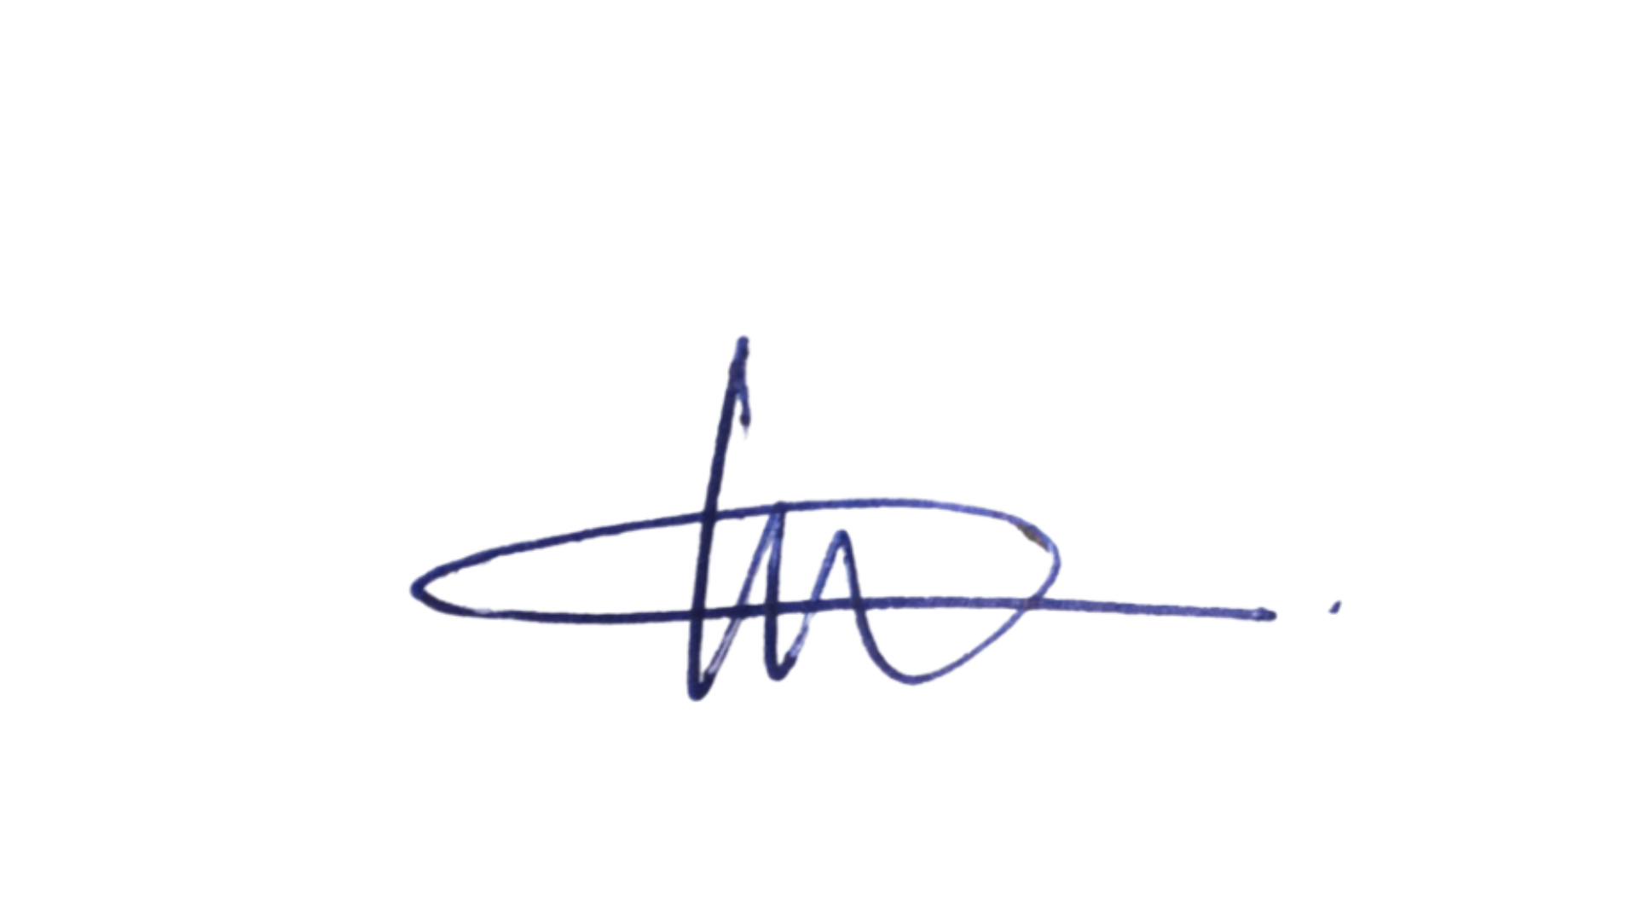10/9/2026
CHAN, Linc Daelen | 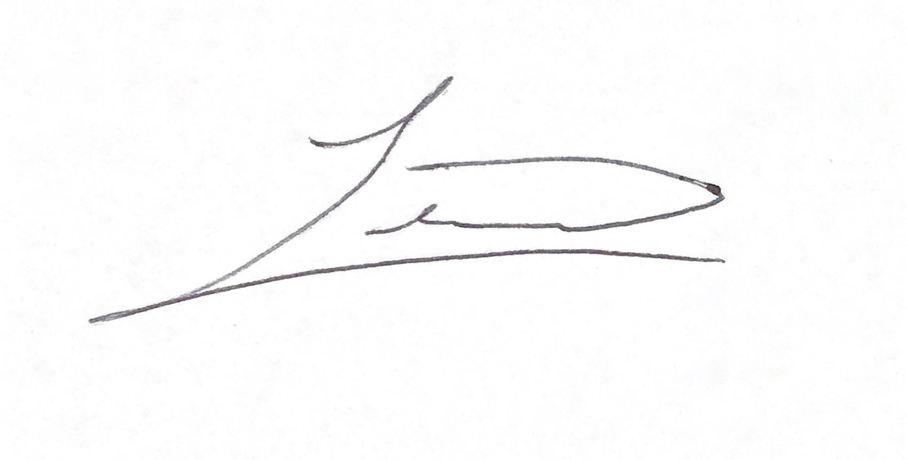10/9/2026

